Submission 0
Name – Kapil sen
Eno. – 22CS002577
Course – B Tech CSE
Section – B,G2

THE CAR RENTAL

Purpose - The main purpose of this website is to provide rental cars to needy this is the solution for individuals arriving from various cities who seek to rent a car at competitive rates. website is designed to provide users with a professional and user-friendly experience and easy to use. provides all types of cars present in the particular city or town.

Target Audience –
The Travelers Individuals traveling for business or leisure who need temporary transportation, Tourists
Visitors exploring new cities or countries who require a reliable means of transportation during their stay. Business Professionals Corporate Travelers in need of a convenient and efficient car rental service for business trips. Event Attendees Individuals attending events, conferences, or weddings who prefer the flexibility of having their rental car.
Design – When a user enters the website, they are prompted to enter their or location. Based on the user's location, website displays a list of cars available for rent in that area. Based on the user's location, the website displays a list of cars available for rent in Udaipur. The list includes cars for rent with timing and pricing details. Otional user can create his/her account and also contact us.

Front page -
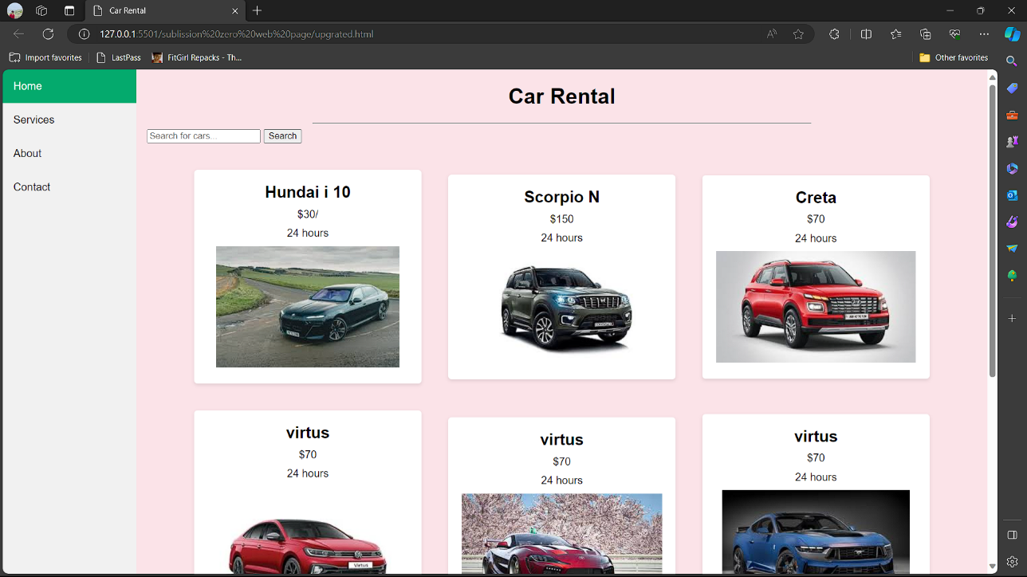

User Interactions - When the user selects the car then clicks "Book Now," guide them through the booking process. Include steps for selecting rental dates, additional options (e.g., insurance, GPS), and payment details Offer both online payment options (credit card, PayPal) and cash payment options for flexibility. After successful booking, display a confirmation page with a summary of the reservation details. Provide instructions on how the user can pick up the car, including the rental location and key retrieval process.
There are basically two different users one in normal person and another one is companies which rent’s the cars in bulk. User can create an account where they asked account for company or an normal user use have to inter the details if company Account then company name required and contact details.
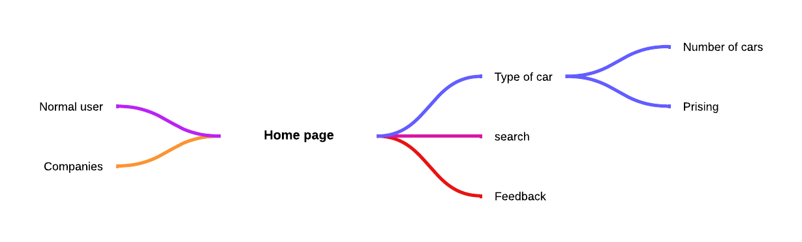

Data Capture –
Users should be able to create an account on your website to manage their bookings, view their rental history, and update their personal information. This page should also include a dashboard with an overview of their account status and any relevant notifications. Implement a secure user authentication system to handle user registrations and logins. Use techniques like password hashing to ensure user security. Develop a system to handle reservations. Implement logic to check car availability based on selected dates and times. Update the database with reservation details. Security Implement security best practices to protect user data and prevent common web vulnerabilities. Use HTTPS, input validation, and secure coding practices.
Error Handling and Logging -
Implement robust error handling to gracefully manage errors and provide meaningful feedback to users. Set up logging to record system activities for debugging and monitoring.

User Account Users should be able to create an account on website to manage their bookings, view their rental history, and update their personal information. page should also include a dashboard with an overview of their account status and any relevant notifications.
For Normal user-
Full Name, Email Address ,Contact Number, Password (for account creation), Address (for billing and communication), Date of Birth (optional for age verification, if needed), Payment Details (credit card information, PayPal, etc.) , Nationality (for potential legal and insurance requirements)
For Corporate User-
Company Name, Business Address, Corporate Email, Contact Person's Full Name, Contact Person's Phone Number, Corporate Identification Number (CIN), Tax Identification Number (TIN), Preferred Payment Method (bank transfer, credit card, etc.)

Flow chart –

User interface :-
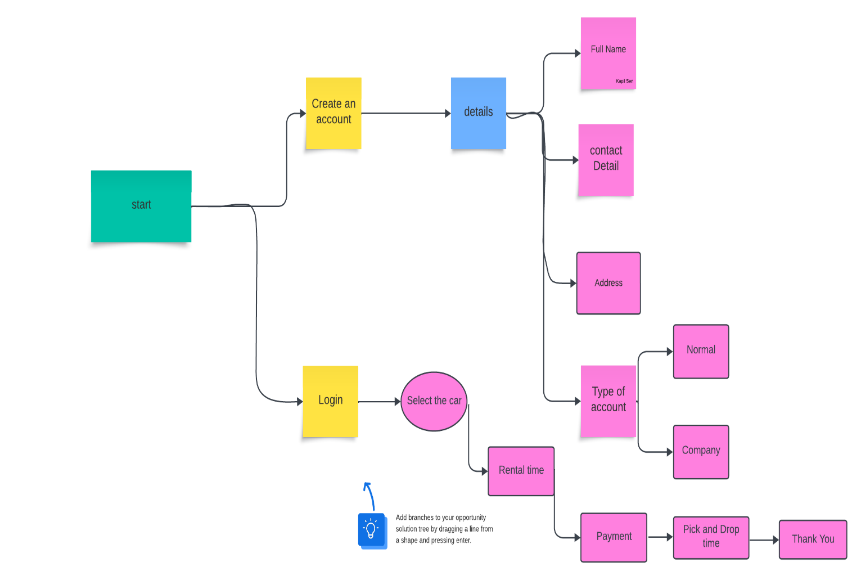

Data Capture Flow:-
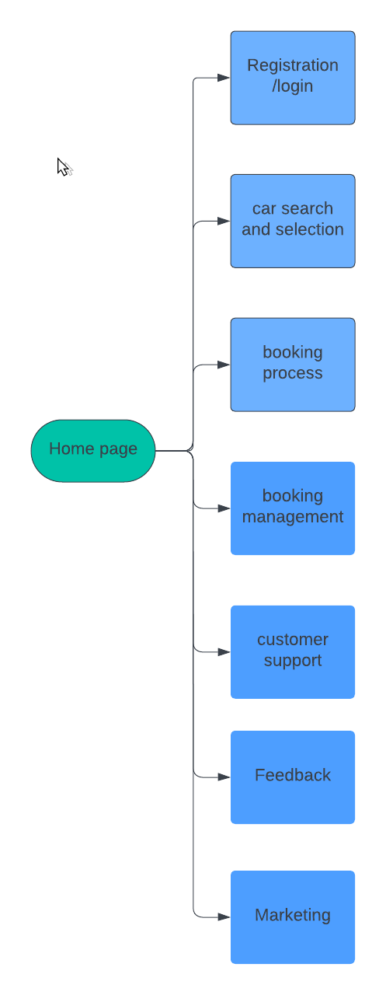

Entities and Attributes:-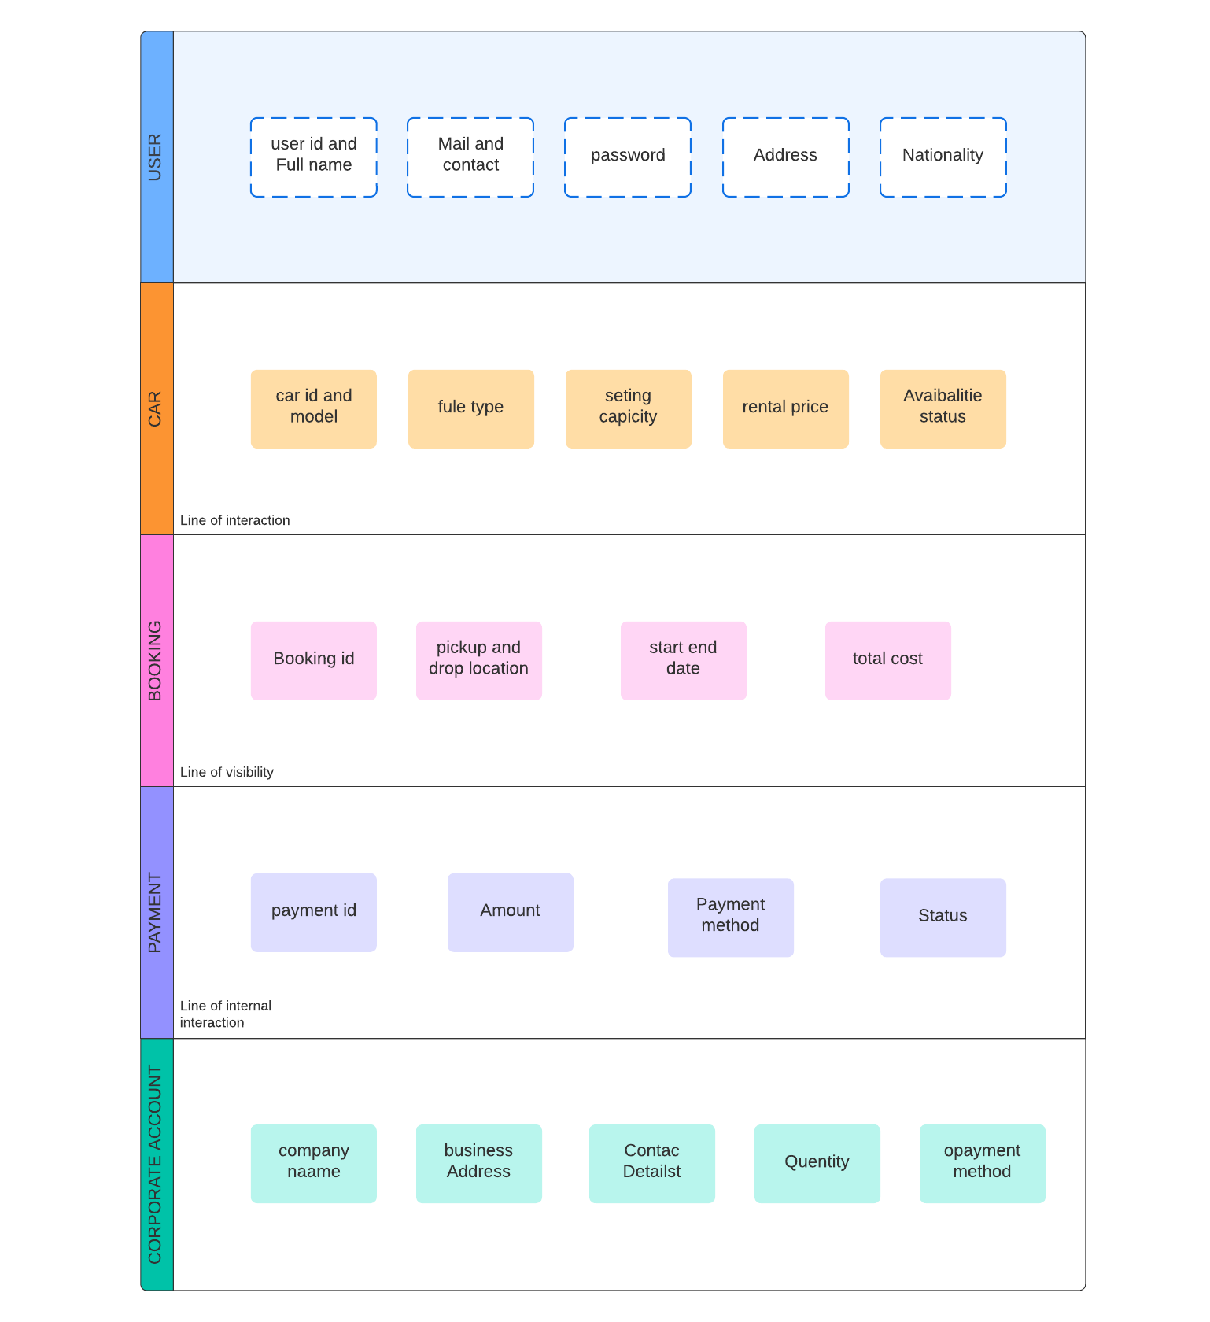
Summary –
Basically Building a car rental website's backend involves strategically combining technology choices, data management, user experience, and security measures. Key steps include: selecting a backend technology (Node.js, Python, Ruby) to handle server-side logic, establishing a database (MySQL, PostgreSQL, MongoDB) to store user, city, car, and reservation data, implementing secure user authentication, populating the database with city and car information, developing APIs to serve frontend requests, creating a booking system to handle reservations, integrating a payment gateway, implementing notifications, crafting an admin panel, prioritizing security best practices, ensuring robust error handling and logging, conducting thorough testing, documenting backend components, designing for scalability, and using version control for code management and collaboration.

